User Guide: Running Advantzware Monitors

| MARCH-21 |

**Document Overview**

**Documentation Goals**

This document is intended to provide instructions for ***Setting up and Running Advantzware Monitors****.*

**Documentation Disclaimers**

This document will NOT:

* Describe the functionality of any individual Monitor program.
* Assist in diagnosing any discrepancies in Monitor program functionality or processing.

**PLEASE NOTE:** This document contains instructions for modifying the Windows System Registry.

Changes made to the Windows registry happen immediately, no backup is created automatically. It is ***STRONGLY*** recommended that you create a backup of the Registry prior to performing any edits. Do not edit the Windows registry unless you are confident about doing so.  
  
Microsoft has issued the following warning with respect to the Registry Editor:  
  
"Using Registry Editor incorrectly can cause serious, system-wide problems that may require you to re-install Windows to correct them. Microsoft cannot guarantee that any problems resulting from the use of Registry Editor can be solved. Use this tool at your own risk."

Table of Contents

What are the Advantzware Monitors? 2

How Do I Run a Monitor? 3

Manual Execution 3

Semi-Automated – Run a Batch File 5

Notes on Selecting the Shortcut Method 6

Automatic Execution Upon Server Startup 6

Teach the Server to Login a User When the System Starts/Reboots 6

Create a Schedule Task to Start a Monitor 9

Questions? 14

# What are the Advantzware Monitors?

Your *Advantzware* system contains several functions which are best run on a *schedule.* This may mean that the function should run every 10 seconds, or every minute, or simply when a user requests a “scheduled task” (like a report).

Obviously, having a user perform these scheduled events manually would not be a good use of time. To solve this problem, ASI created a set of “*Monitor Tasks*” that can perform these scheduled processes automatically.

Tasks that have associated Monitor programs are:

* API Monitor
* cXML Monitor
* Esko Monitor
* FG XML Monitor
* Rel XML Monitor
* RFID Monitor
* ScheduleMonitor
* TaskMonitor
* User Monitor

Any of these monitors may, or may not be available to your organization, depending on your company needs. Some monitors may be available for a small additional charge to your *Advantzware* license fee.

If you believe you may find one or more of these Monitors useful, please contact your *Advantzware* *Sales Representative* for additional details.

# How Do I Run a Monitor?

## Manual Execution

The easiest method of running a Monitor is to log on to your server as a member of the Administrators group, run the *Advantzware* login program, and select the Monitor from the “*Modes*” drop-down option:

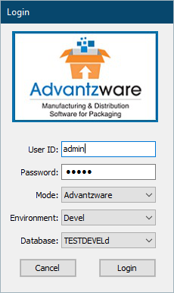 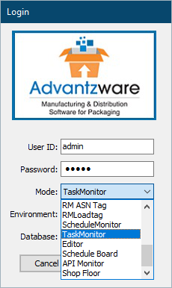 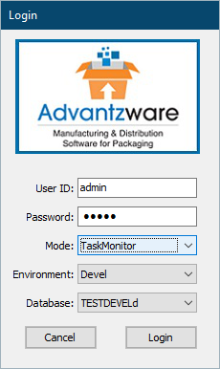

Using this method, you may also select a particular Environment and/or Database if you have multiple Environments installed on your server.

Once you have chosen a Monitor, the Login screen will disappear, and the selected Monitor function will be displayed.

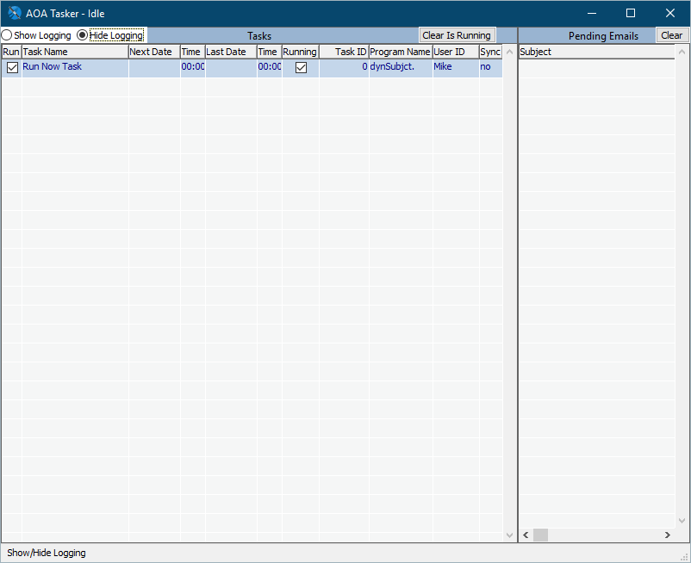

At this point, the Monitor will continue to process operations until you close it (normally by using the Window Close button at the top right of the screen).

You can also *minimize* this window to the Windows Toolbar/Tray without affecting the operation of the Monitor.

## Semi-Automated – Run a Batch File

If you wish to run multiple Monitors, it may be easier to use a more automated process. To facilitate this, more recent version of the *Advantzware* system provide a group of Windows Shortcuts that allow you to start individual Monitors with a “double-click”.

These shortcuts have been placed in your *Advantzware* system folder in the subfolder “Desktop/RunOnServerOnly”.

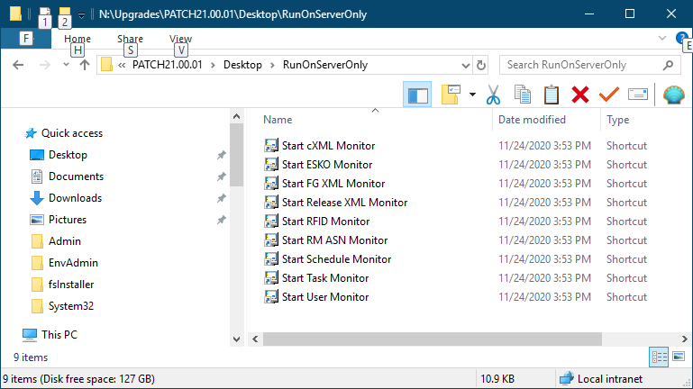

These shortcuts, *as-is,* will be suitable for most customers, and can be copied to your server desktop and run as desktop shortcut icons.

Please Note: Some customers have installations that can prevent the delivered shortcuts from running properly.

In this case, you should open the “Properties” dialog for the desired shortcut and make any necessary changes to either the “Target:” or “Start in:” fields:

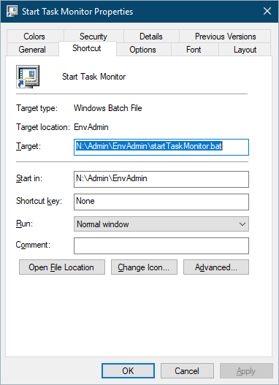

This issue may arise if your ASI “mapped drive” is not the typical “N:” drive.

Please Note: That the delivered shortcuts will ONLY allow you to run these automated Monitors in your “Prod” environment, and use the “asiProd” database.

If you would like to use one or more of the automated monitors in a TEST environment, please contact *Advantzware* support for more assistance.

### Notes on Selecting the Shortcut Method

If you elect this method of starting one or more Monitors, and if you have a “non-standard” installation (your mapped drive is NOT drive N:), make sure to copy the delivered shortcut to your server desktop prior to modifying it.

Any *Advantzware* upgrade is subject to overwriting the shortcuts in the /Desktop/RunOnServerOnly folder.

## Automatic Execution Upon Server Startup

You can have one or more monitors start *when the Server starts or reboots,* but the process to make this happen is complex, involves changes to the server registry, and the creation of one or more *Scheduled Tasks* in the Windows system. Instructions for this process follow:

### Teach the Server to Login a User When the System Starts/Reboots

This section will cause the server to automatically log in a user when the computer starts. As mentioned above, the Advantzware Monitors have a visualized user interface, and without a logged in user, there is no “place” for this interface to display.

Please Note: The following instructions are based on an official Microsoft document, which can be found [here](https://docs.microsoft.com/en-us/troubleshoot/windows-server/user-profiles-and-logon/turn-on-automatic-logon).

*You should be familiar with the use of the RegEdit program prior to using this feature.*

#### Steps:

1. Log into the server as the server Administrator.
2. Click “***Start”***, then click “***Run”***.
3. In the Open box, type “regedit.exe” (without quotes), and press “***Enter”.***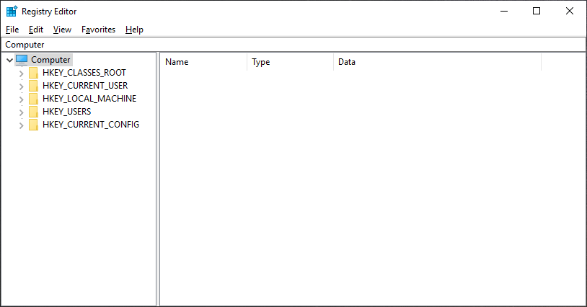
4. From the menu bar, choose File | Export and enter a filename for the backup of the Registry prior to making any edits:  
     
   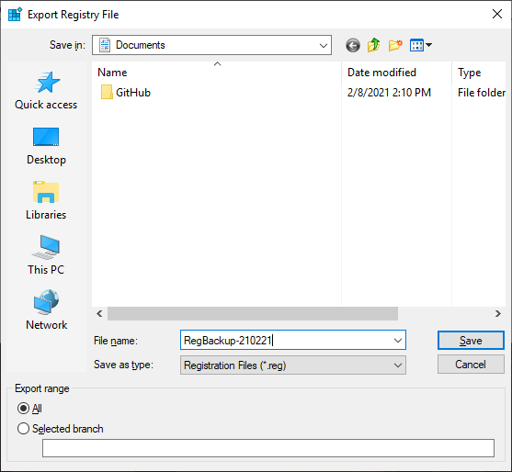
5. Press “***Save”*** to complete the registry backup.
6. Navigate the Registry to find the HKEY_LOCAL_MACHINE\SOFTWARE\Microsoft\Windows NT\CurrentVersion\Winlogon subkey.  
     
   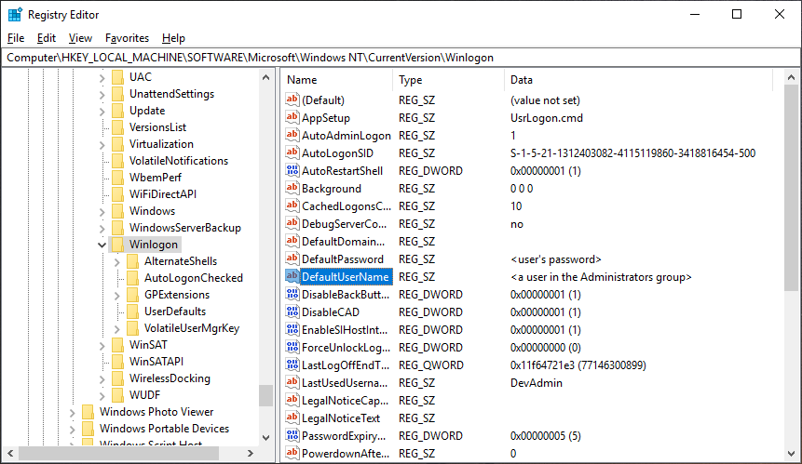
7. Double-click the DefaultUserName entry, enter the UserID you want to automatically log in on server start up, and press “***Enter”***.  
     
   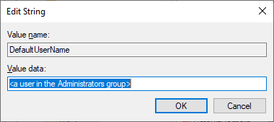
8. Double-click the DefaultPassword entry, enter the selected user’s password, and press “***Enter”***.  
     
   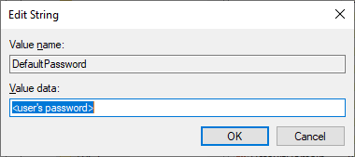  
     
   1. Please Note: This password will be stored in the Registry in ***PLAIN TEXT***, and will be visible to any user in the Administrators group who has access to the RegEdit program.
   2. If the “DefaultPassword” entry does not exist, it must be added as follows:
      1. On the Edit menu, click “***New”***, then select *String Value*.
      2. Type DefaultPassword, then press “***Enter”.***
      3. Double-click DefaultPassword.
      4. In the *Edit String* field, enter the password then click “***OK”.***
9. On the Edit menu, click “***New”***, the select *String Value*.
10. Type AutoAdminLogon and press “***Enter”***.
11. Double-click *AutoAdminLogon.*
12. In the *Edit String* field, type 1 and then click “***OK”.***
13. Exit the Registry Editor.

### Create a Schedule Task to Start a Monitor

Windows contains a built-in Task Scheduler that is capable of running programs either on a timed basis, or based on the occurrence of certain events. In this section, we will create a Scheduled Task that will run 3 minutes after the server starts or is rebooted. (The 3 minute delay is critical, and gives the databases time to start for a valid connection to be made by the Monitor program.)

#### Steps:

1. From the Start menu, select Administrative Tools, then choose the Task Scheduler option.
   1. Your “***Start”*** button may present various displays. Two common options are as follows:  
        
      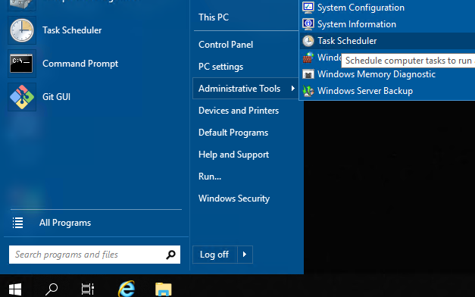 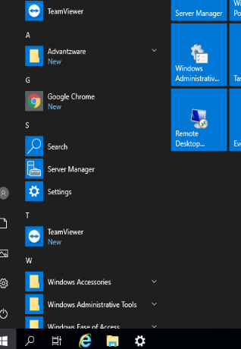  
      (Where “Windows Administrative Tools” is the proper choice.)
   2. The Task Scheduler should appear:  
        
      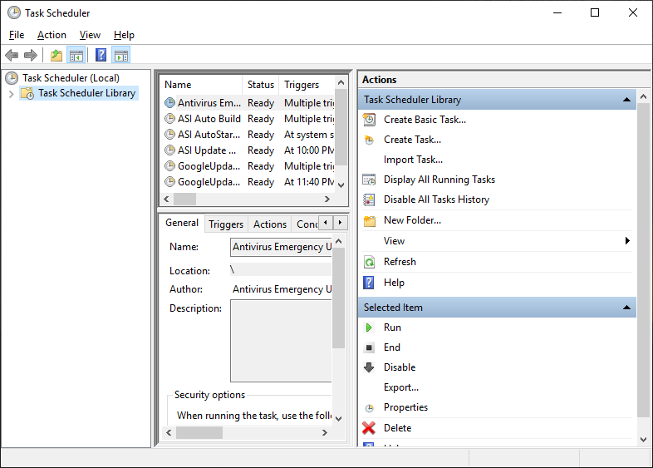
2. Click on the Task Scheduler Library option on the left, then click Create Basic Task on the Actions menu on the right.  
     
   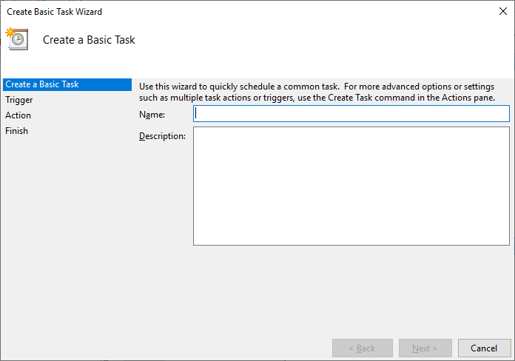
3. Enter a name for this task “ASI AutoStart Task Monitor” (or similar), and press Next
4. Select “When the computer starts” and press Next  
     
   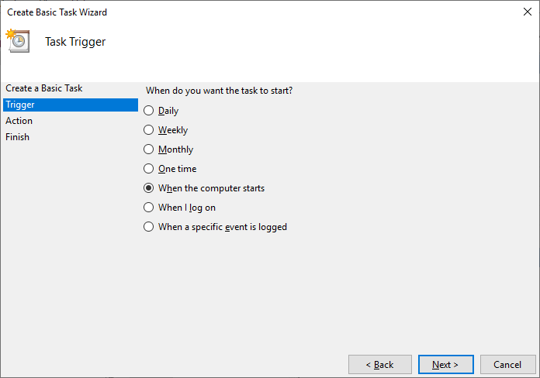
5. Click “Start a program” and press Next  
     
   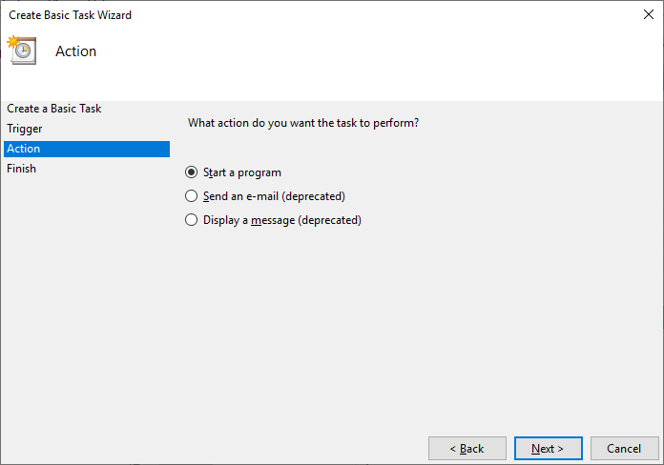
6. Choose the Browse button, navigate to the folder containing the StartTaskMonitor.bat batch file (Normally C:\asigui\Admin\EnvAdmin):
7. Click in the Address bar at the top, and copy (Ctrl-C) the directory name to your clipboard, so it can be pasted in the locations desired later. Double-click the StartTaskMonitor.bat file to set the batch file name.  
     
   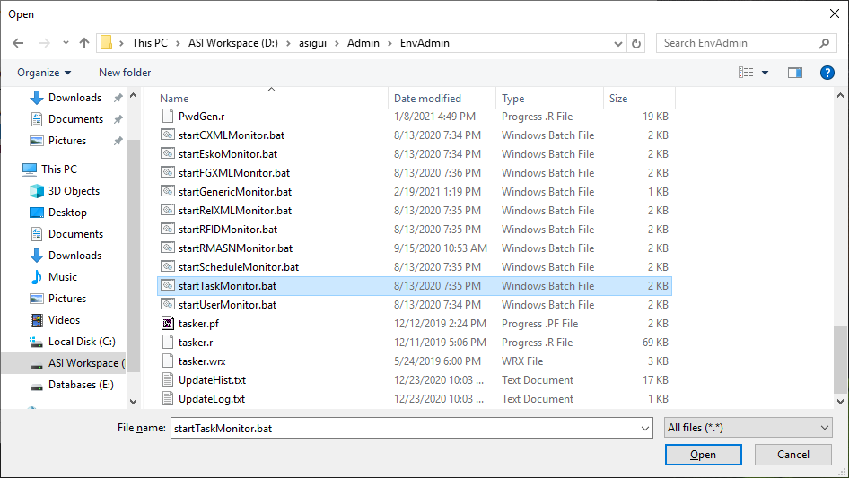
8. Tab to the “Start in (optional): field and paste (Ctrl-V) your clipboard entry there:  
   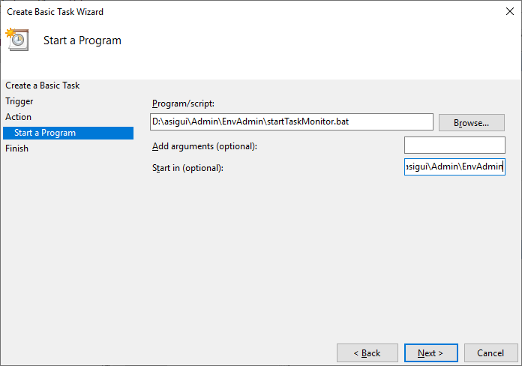
9. Press Next.
10. Select the “Open the Properties dialog for this task when I click Finish” option, and press Finish.  
    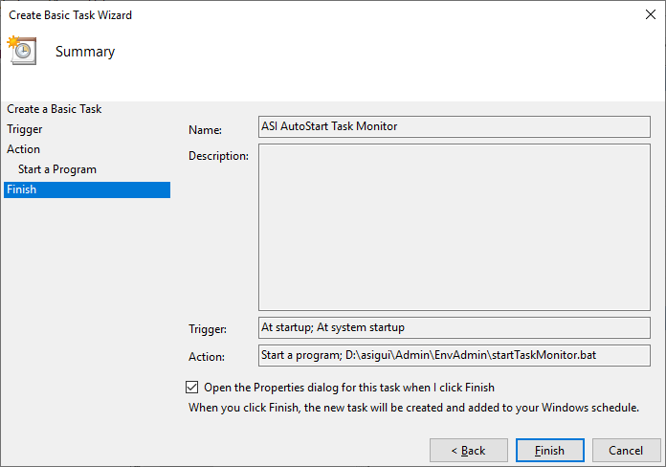
11. On the Properties dialog, click the Triggers tab:  
      
    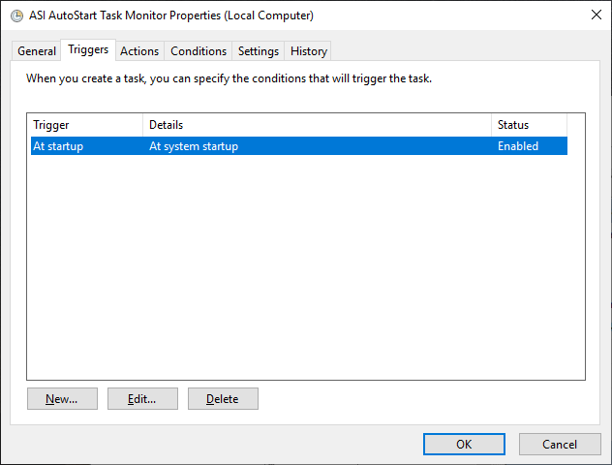
12. Highlight the “At startup” option, then press Edit:  
      
    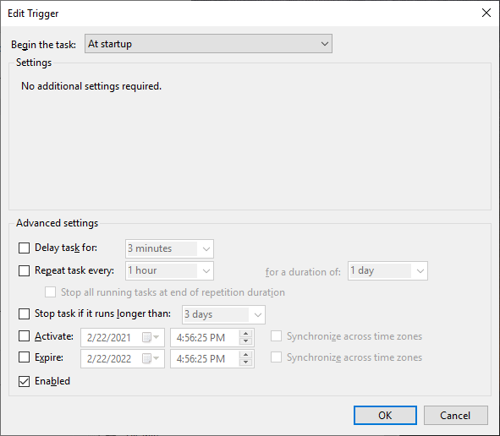
13. Choose the “Delay task for:” option and enter “3 minutes”:  
      
    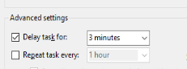
14. Click OK, then click OK again.

The Task Monitor is now scheduled to start automatically when the server is started or rebooted. To schedule additional Monitors, repeat steps 1 through 14 for each Monitor you want to start on system start.

# Questions?

For more information on this topic, or if you would like to schedule an ASI Support representative to assist with this process, please contact Advantzware Support at:

[help@advantzware.zohosupport.com](mailto:help@advantzware.zohosupport.com)